ARTIFICIAL INTELLIGENCE AND MACHINE LEARNING

Building Neural Networks for Classification and Regression
Team Member 1 | Motaz Elmashaleh
Team Member 2
Due Date | 25 August 2026


1. Introduction
In this assignment, I used neural networks for two different machine learning tasks. The first task was classification using the Fashion-MNIST dataset, and the second task was regression using the California Housing dataset.
For each part, I prepared the data, built a neural network, trained it, and checked its performance. I also tried two different versions of each model to see if changing the architecture could improve the results.
2. Classification – Fashion-MNIST
2.1 Dataset
Fashion-MNIST contains 70,000 grayscale images of clothes. Each image is 28 × 28 pixels and belongs to one of 10 classes.
The data was divided into:
- 55,000 images for training
- 5,000 images for validation
- 10,000 images for testing
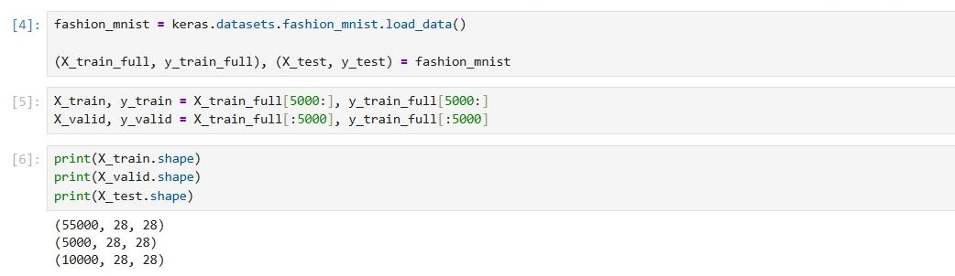

2.2 Data Preparation
The pixel values were originally between 0 and 255. I normalized them to values between 0 and 1 by dividing by 255.
I also used a Flatten layer in the model. This changes each 28 × 28 image into 784 values before sending it to the Dense layers.
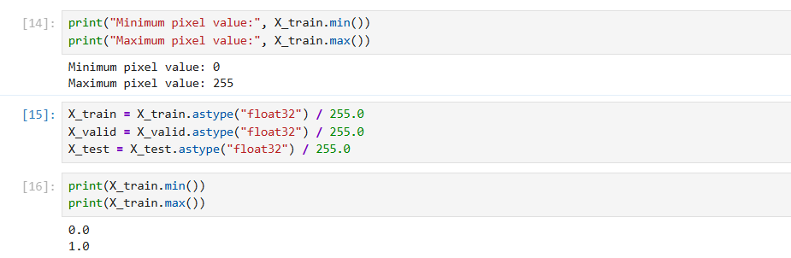

2.3 Baseline Model
For the first model, I used a simple neural network with two hidden layers. The first hidden layer had 300 neurons and the second had 100 neurons. ReLU was used as the activation function for both layers. The output layer had 10 neurons with Softmax because the dataset has 10 different classes.
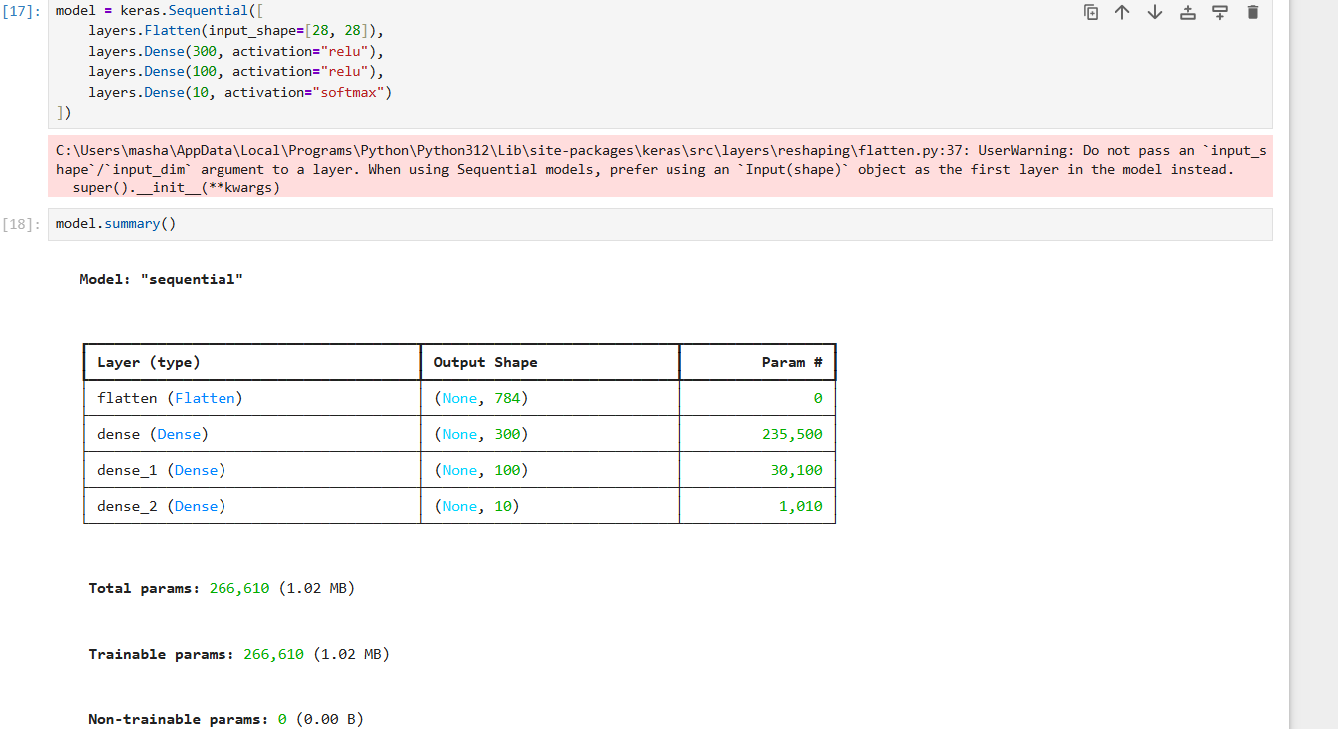
Before training, the model was compiled using the Adam optimizer. I used Sparse Categorical Crossentropy as the loss function since the class labels are represented by numbers from 0 to 9. Accuracy was used to measure the model performance during training.

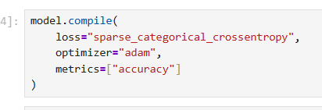
The model was then trained using the training set while the validation set was used to check its performance during the training process.
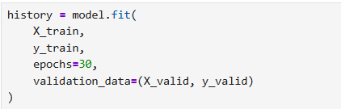

2.4 Results
After training the baseline model, I evaluated it using the test dataset.
The model achieved a test accuracy of around 89%, which means that most of the Fashion-MNIST images were classified correctly.
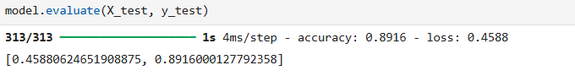
I also calculated the precision, recall, and F1-score. The values were also close to 89%, showing that the model had similar performance across the different evaluation measures.
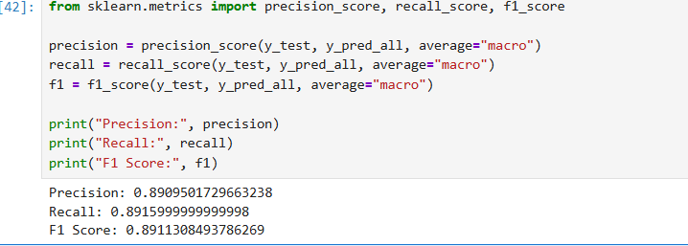
A confusion matrix was used to see which classes were predicted correctly and where the model made mistakes.
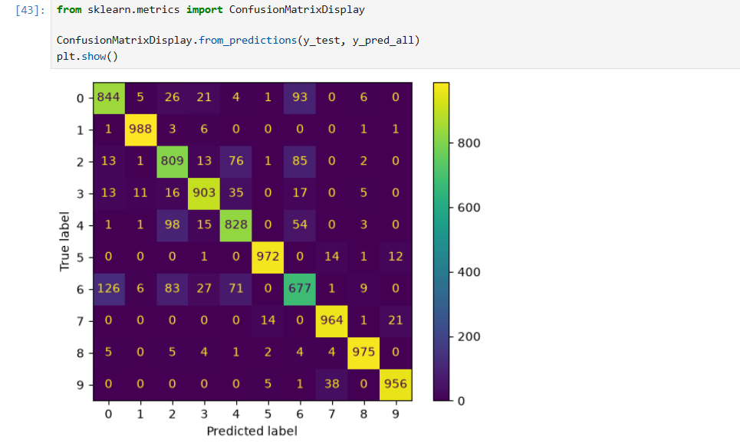
I also plotted the training and validation accuracy to see how the model improved during training.
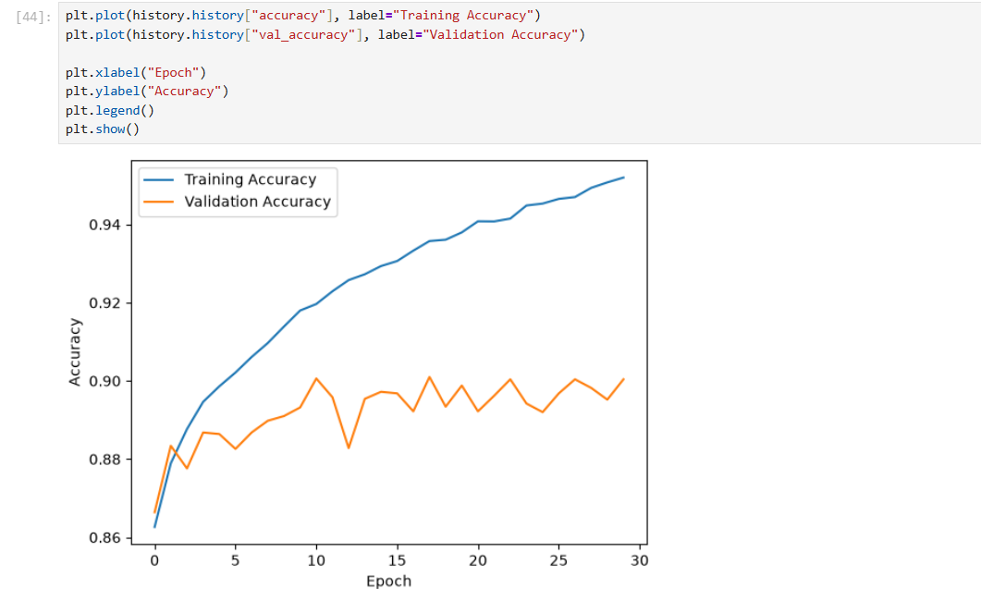
The training and validation loss were plotted as well.
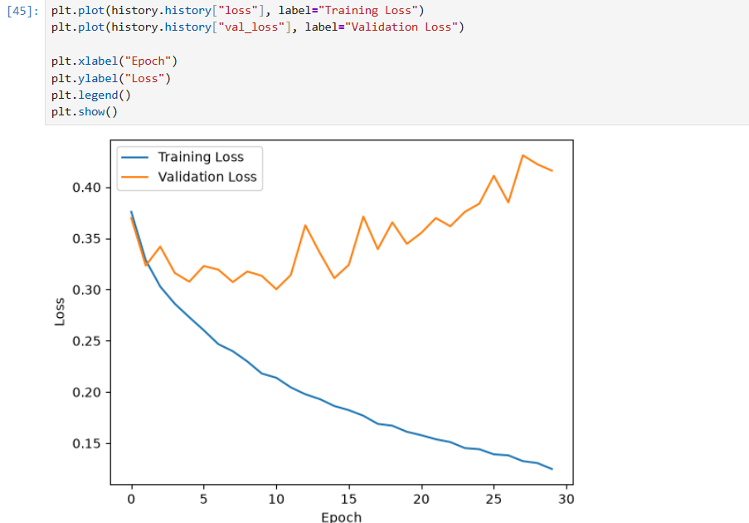
The training results continued to improve more than the validation results in the later epochs. This indicates that the model started to show some overfitting.
Finally, I displayed 10 incorrectly classified images to examine the types of mistakes made by the model.
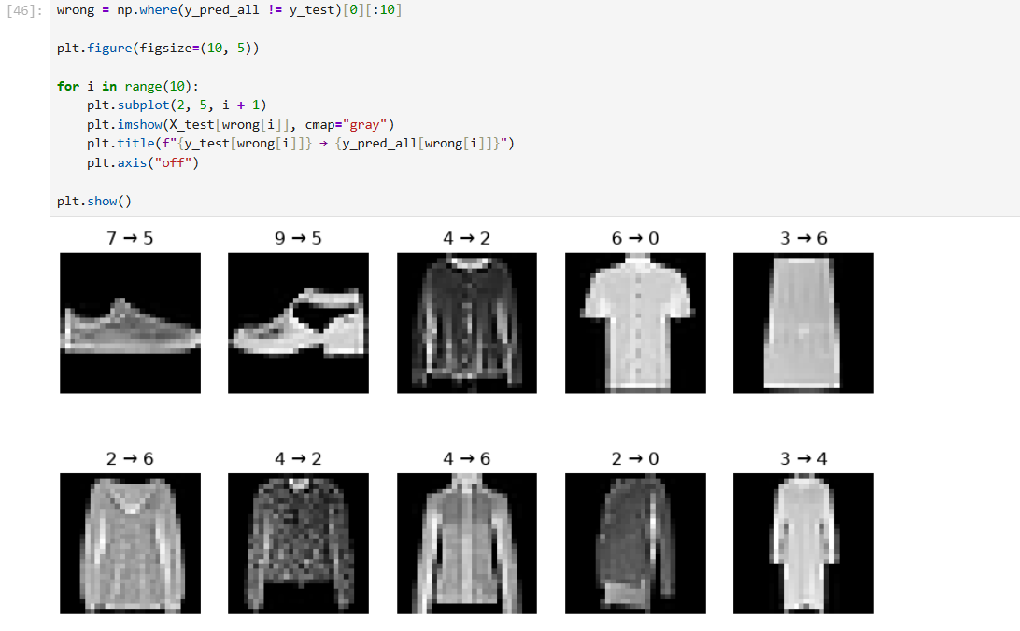Most of the mistakes were between clothing classes that have similar shapes, such as shirts, T-shirts, pullovers, and coats.
2.5 Wrong Predictions
I displayed 10 images that were classified incorrectly.
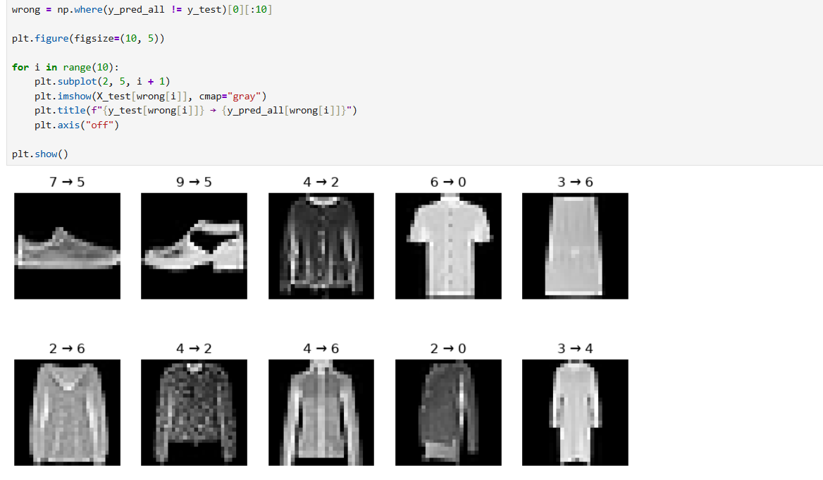Most of the mistakes were between similar types of clothes. For example, shirts, T-shirts, coats, and pullovers can look similar because the images are small and grayscale.
2.6 Experiments
Two more models were tested.
Experiment 1
For the first experiment, I increased the number of neurons.
The model used:
400 → 200 → 10
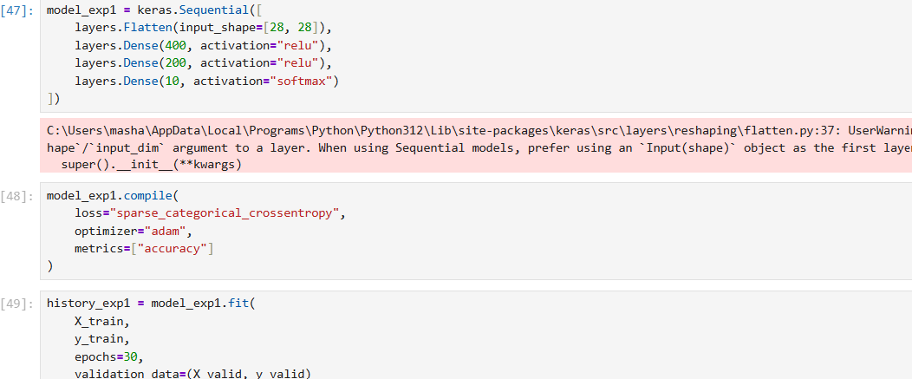
The result was close to the baseline model, but it did not improve the accuracy.
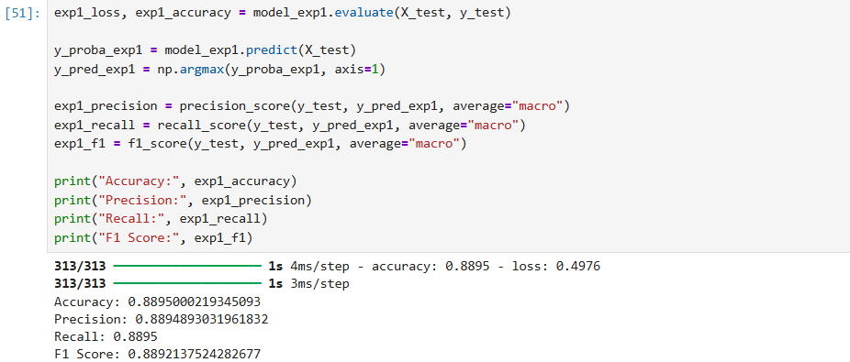
Experiment 2
For the second experiment, I added Dropout layers.
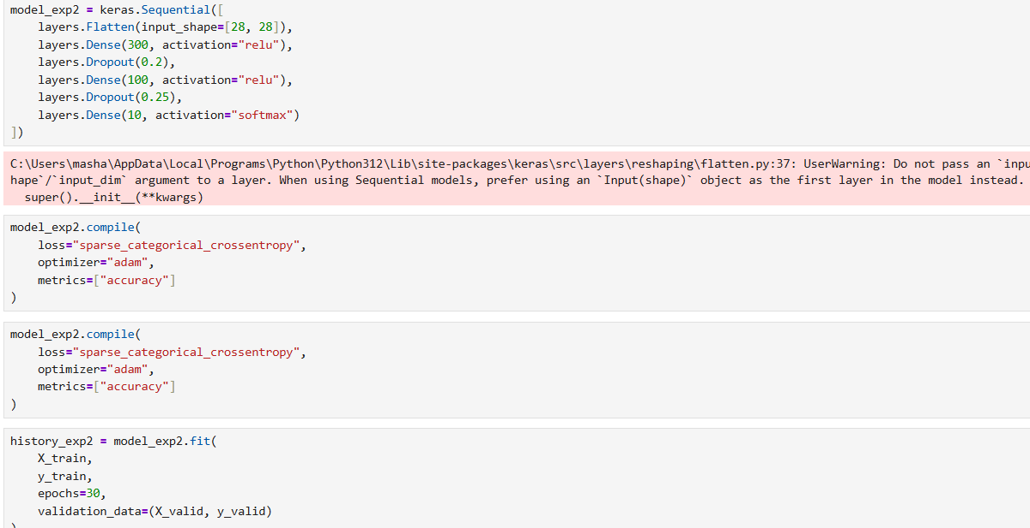
The purpose of Dropout was to reduce overfitting by randomly ignoring some neurons during training.
The result was also slightly lower than the baseline model.
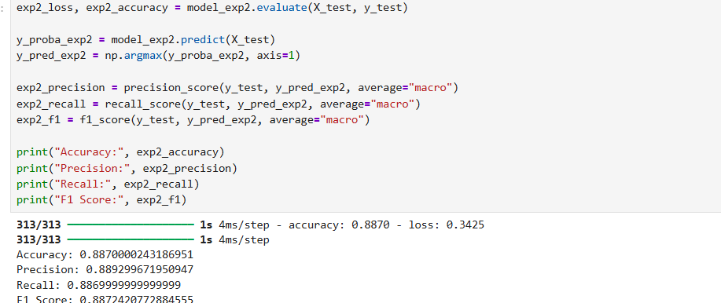
2.7 Model Comparison
Model | Accuracy | Precision | Recall | F1-Score
Baseline | ~0.892 | ~0.891 | ~0.892 | ~0.891
Experiment 1 | ~0.890 | ~0.889 | ~0.890 | ~0.889
Experiment 2 | ~0.887 | ~0.887 | ~0.887 | ~0.887
The baseline model was the best in this part.
Increasing the number of neurons did not improve the result, and adding Dropout also gave a slightly lower result. This shows that making a model more complicated does not always make it better.

3. Regression – California Housing
3.1 Dataset
In the second part, I used the California Housing dataset for a regression problem. The goal was to predict the median house value using 8 numerical features such as median income, house age, number of rooms, population, latitude, and longitude.
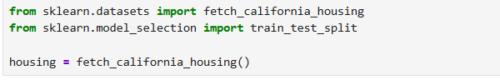
The dataset contains 20,640 samples and 8 input features.
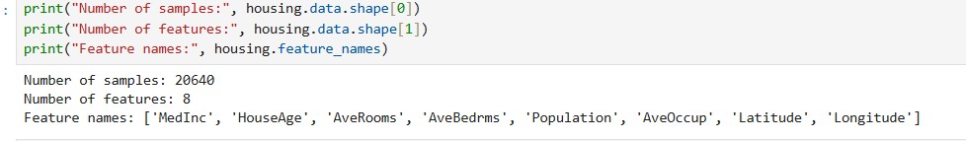
Before building the model, I checked the dataset using descriptive statistics and also checked for missing values. No missing values were found.
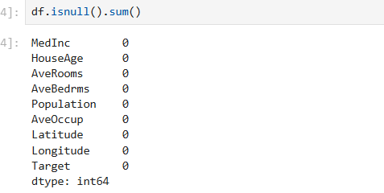
I also plotted the distribution of the target values.
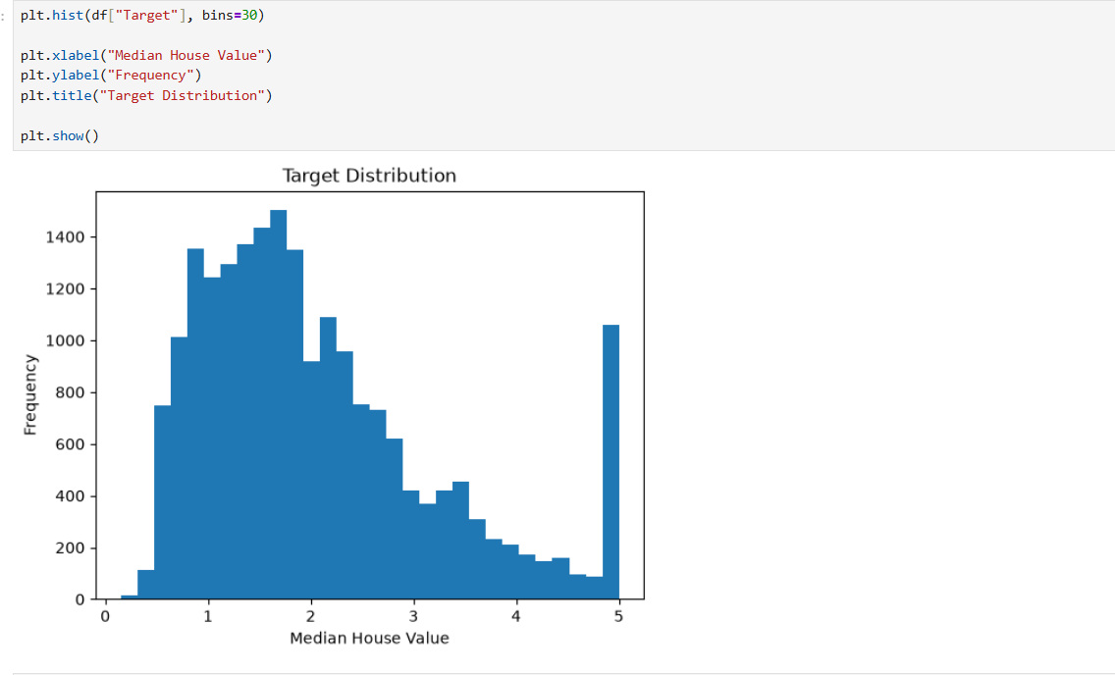
A correlation matrix was calculated to see the relationship between the features and the target. Median income showed one of the strongest relationships with the house value.
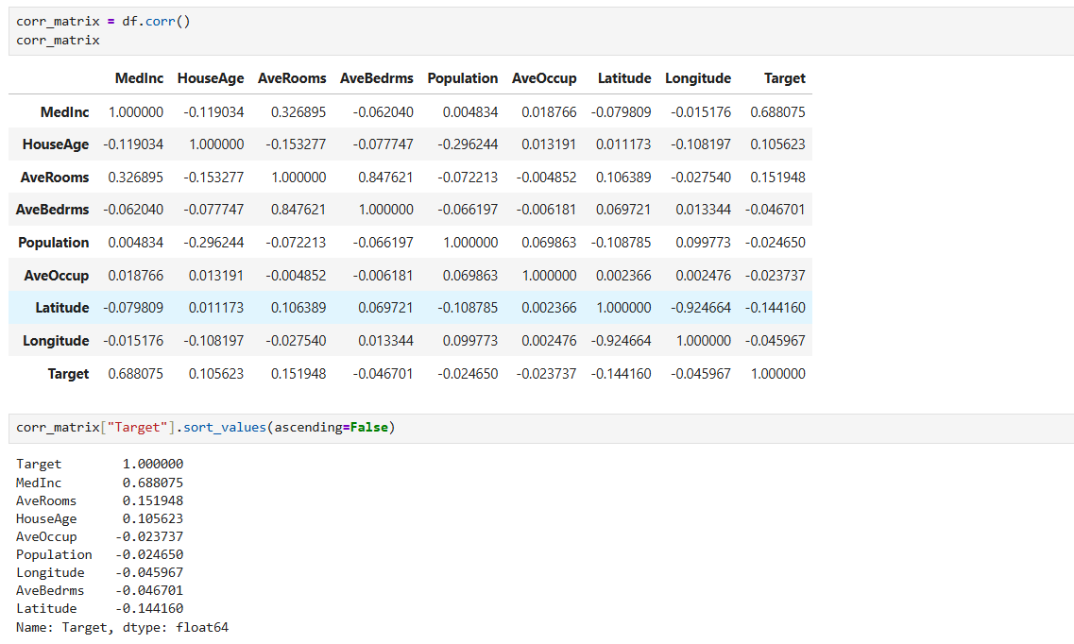
3.2 Data Preprocessing
The dataset was divided into 80% training data and 20% testing data. The training data was then divided again into training and validation sets.
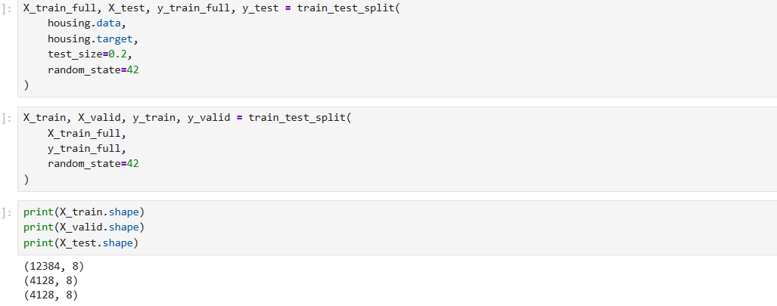

Since the input features have different ranges, I used StandardScaler to standardize them.
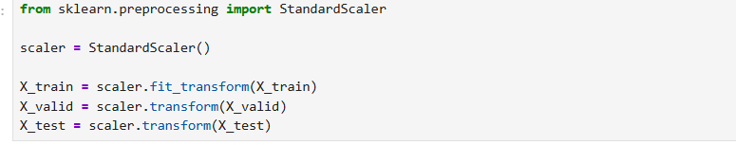
The scaler was fitted only on the training data, then the same scaler was applied to the validation and test data.
3.3 Baseline Model
The baseline neural network contained three hidden layers:
64 → 32 → 16 → 1
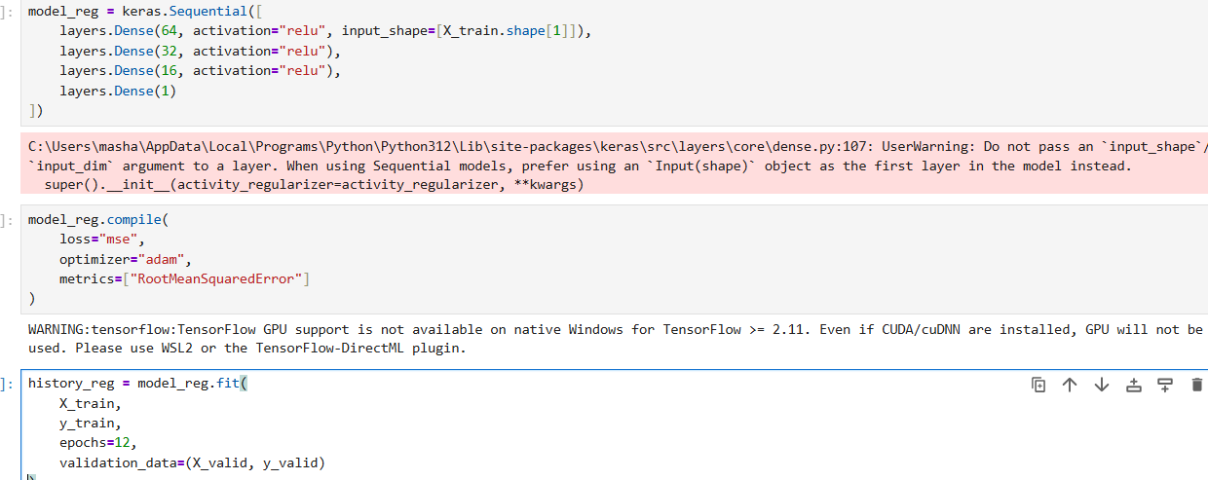
ReLU activation was used in the hidden layers. The output layer contained one neuron because the model predicts one continuous value.
The model was compiled using the Adam optimizer, Mean Squared Error (MSE) as the loss function, and RMSE as the evaluation metric.
The model was trained for 12 epochs using the training set, while the validation set was used to monitor the model during training.
3.4 Results
After training, the model was evaluated using the test data.
The baseline model achieved the following results:
- MAE = 0.3881
- MSE = 0.3060
- RMSE = 0.5531
- R² = 0.7665
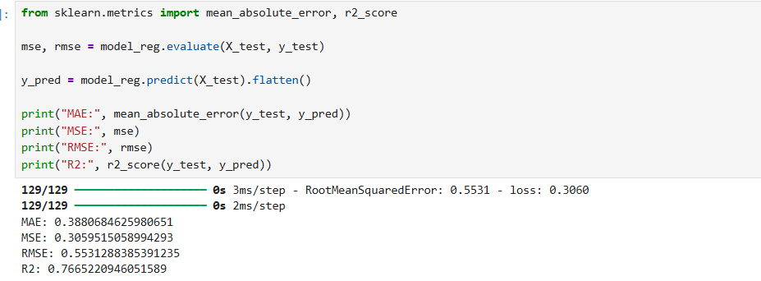
The training and validation loss were plotted to see how the model learned during the epochs.
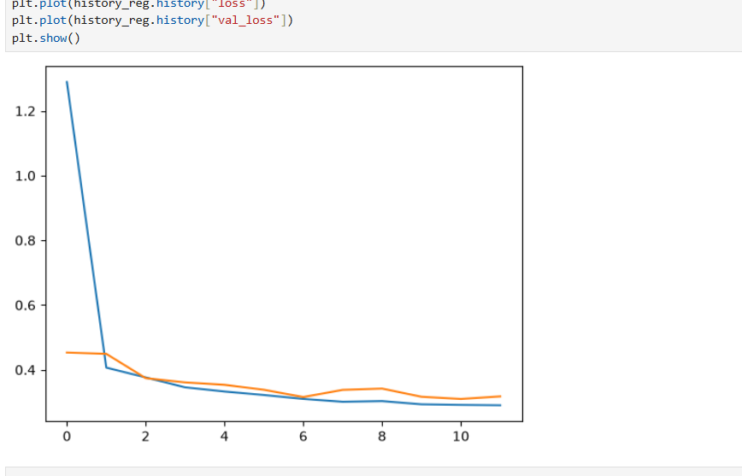I also plotted the training and validation RMSE.
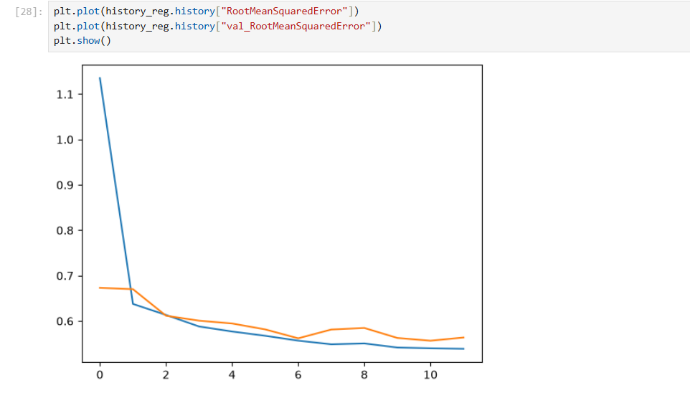
Finally, I compared the actual house values with the predicted values using a scatter plot.
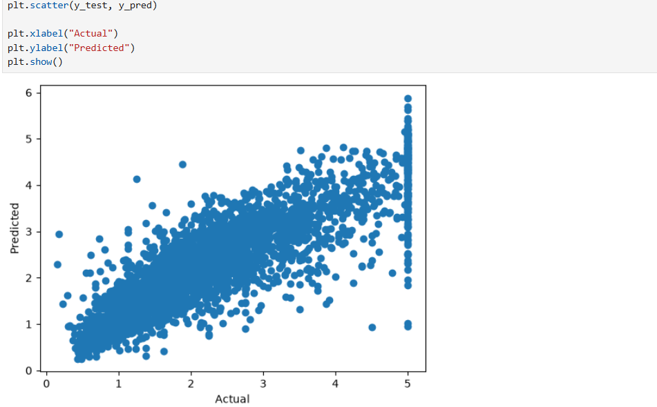The results show that the model was able to make reasonable predictions, although there were still some differences between the actual and predicted values.
3.5 Additional Experiments
Two additional models were tested to see if changing the architecture could improve the results.
Experiment 1
In the first experiment, I increased the number of neurons.
The architecture was:
128 → 64 → 32 → 1

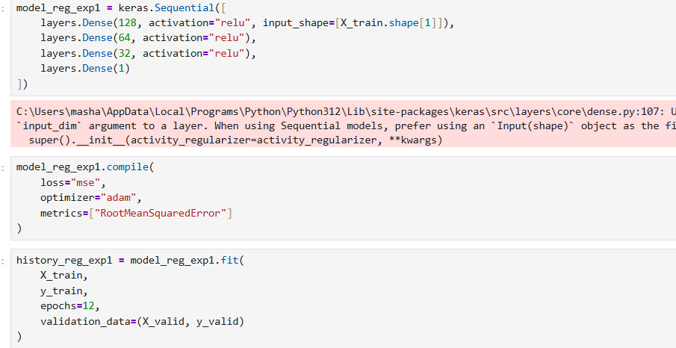
The results were:
- MAE = 0.3842
- MSE = 0.3011
- RMSE = 0.5488
- R² = 0.7702
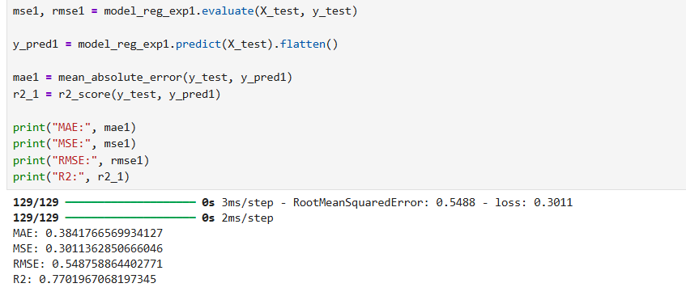
Experiment 2
In the second experiment, I added Dropout layers to the model.
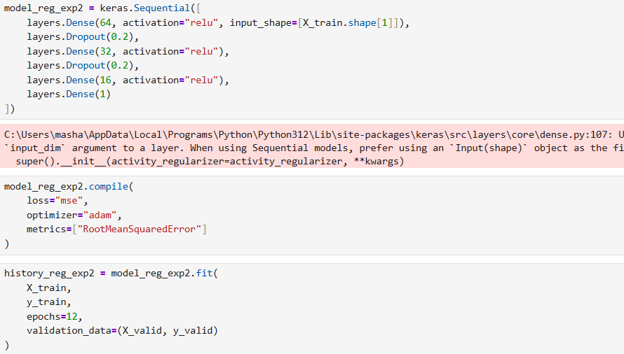
The results were:
- MAE = 0.3995
- MSE = 0.3246
- RMSE = 0.5698
- R² = 0.7523
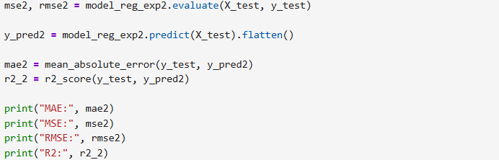
3.6 Model Comparison
Model | MAE | MSE | RMSE | R²
Baseline | 0.3881 | 0.3060 | 0.5531 | 0.7665
Experiment 1 | 0.3842 | 0.3011 | 0.5488 | 0.7702
Experiment 2 | 0.3995 | 0.3246 | 0.5698 | 0.7523
Experiment 1 gave the best result because it had the lowest MAE, MSE, and RMSE, and also the highest R² value.
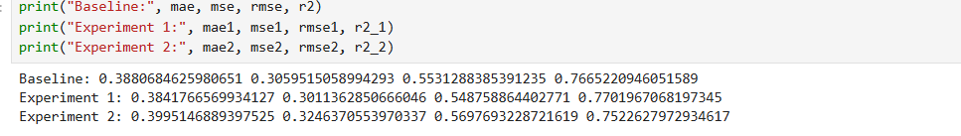
The improvement over the baseline model was small, but increasing the number of neurons helped the model slightly. The Dropout model gave the weakest result in this experiment.

